BASH SCRIPTING -ASSIGNMENT 01
Bash Scripting : Instead of executing commands manually I have automated this process without any manual intervention where the given commands are executed.
Shell
Shell is an interface between users and kernel / OS
To find shell
echo $0 Which shell you are using
Find your shell?We use following commands
cat /etc/shells – list of shells which are available
cat /etc/passwd To know which shell
To switch to any particular shell
- I am switching to csh, I gave csh and enter
- Next I have checked using echo $
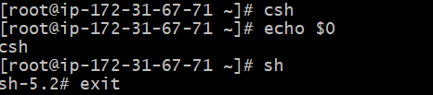
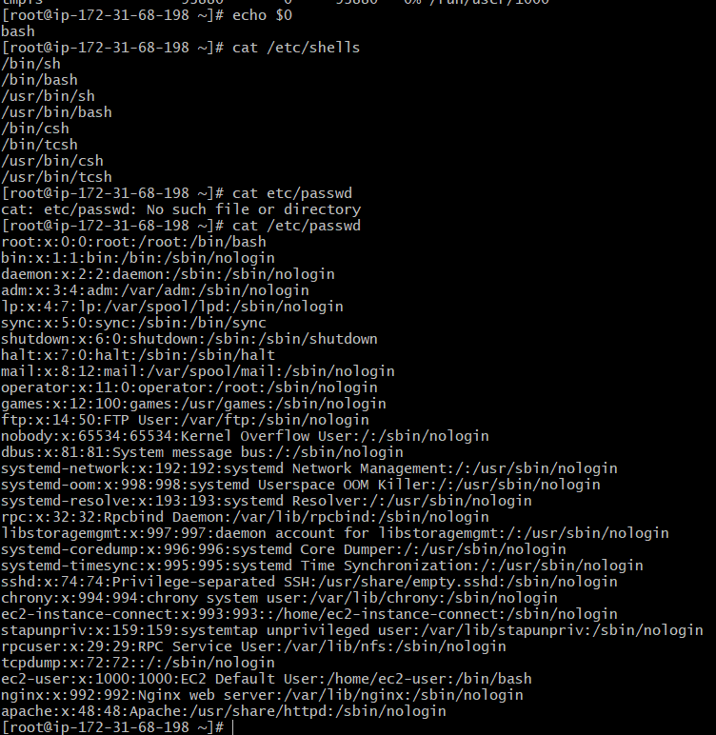

How to run a script:
Absolute Path : It gives complete location of a file or directory from the root directory.
I have created directory called scripts.
1)Absolute Path:
Basic hello world script: I have created script called Hello World
Basic commands script: I have created script using echo as a command.
To change the permissions I used command called chmod 777 where I am giving whole permissions.

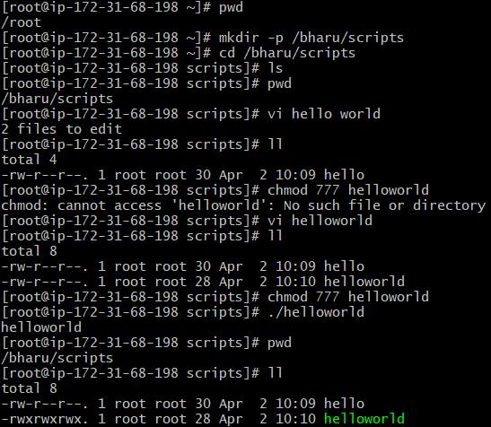
2)Relative path:
Relative Path : It specifies the location of a file relative to our current directory
I have executed script from root location and passed the directories and scriptname name to get into relative path.
Create an extension for script
To identify it is a bash script we need to create an extension.Here I have used the command
mv helloworld helloworld.bash

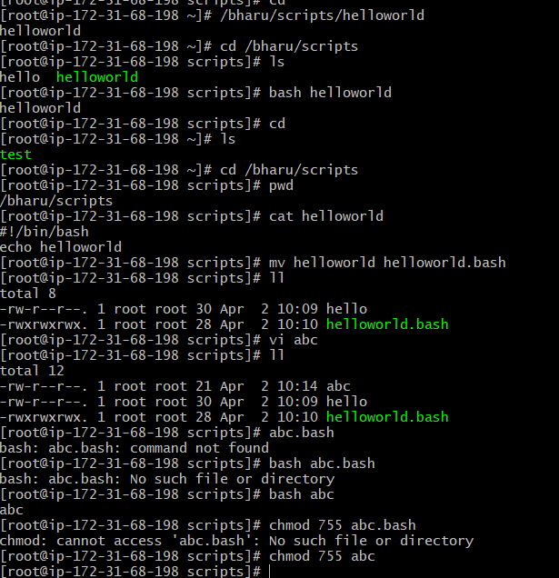
Script Format:
Steps which will help the other users to understand
Script File Permissions:
All scripts to be executed should have proper executable file permissions
- I have created a bash name abc.bash
- I have given the permissions as 755

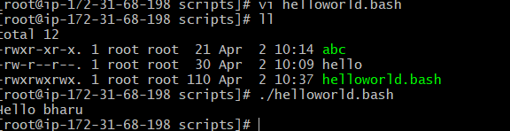
We can add lines between our output to make it look better
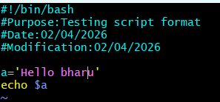

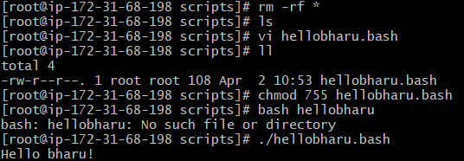
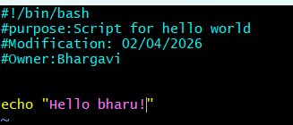
If we want to search a line we have to give :5
Basic Shell scripts:
Create a basic script script with output:Hello bharu!
Basic second scripts:
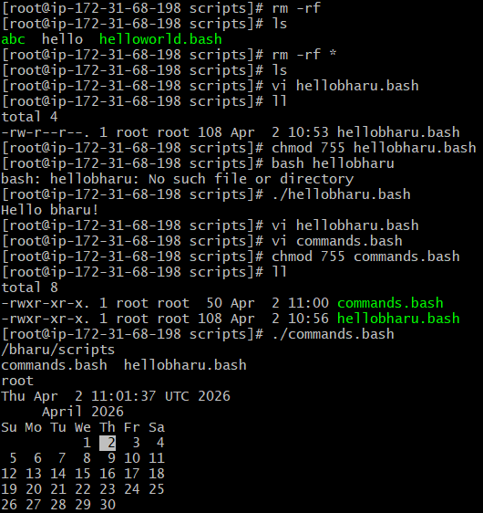

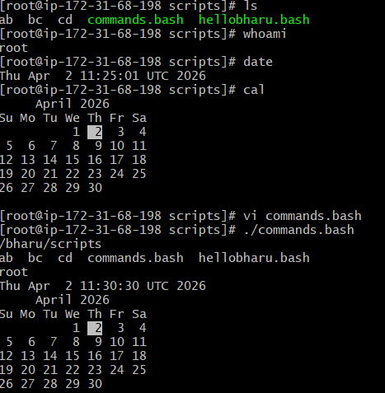

Cursor will go directly to 5th line. 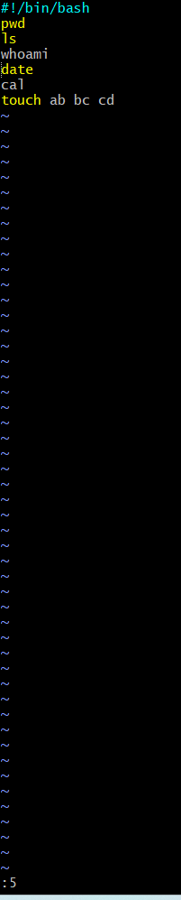

Basic Administration Tasks: I have created one more scripts as admin.bash with some commands

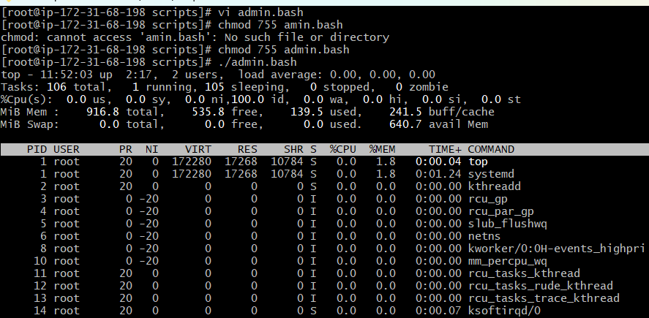
We have to get top command only executed because top command will hold the session and continue monitoring.
vi admin.bash
we have to enter head -10
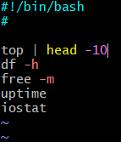
./admin.bash
We got this below output.
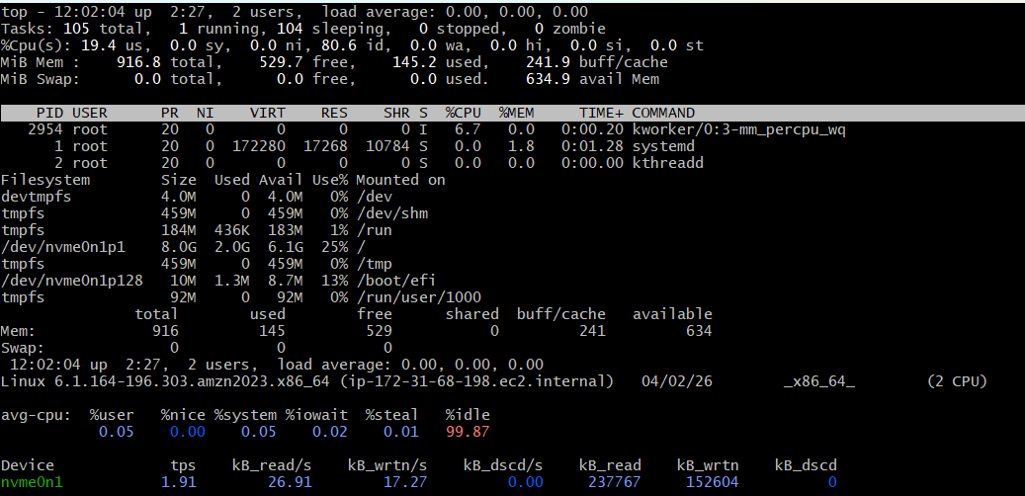
Defining Variables:
Here I am executing in terms of variable. I have created a script as variables.bash
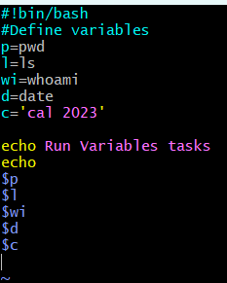
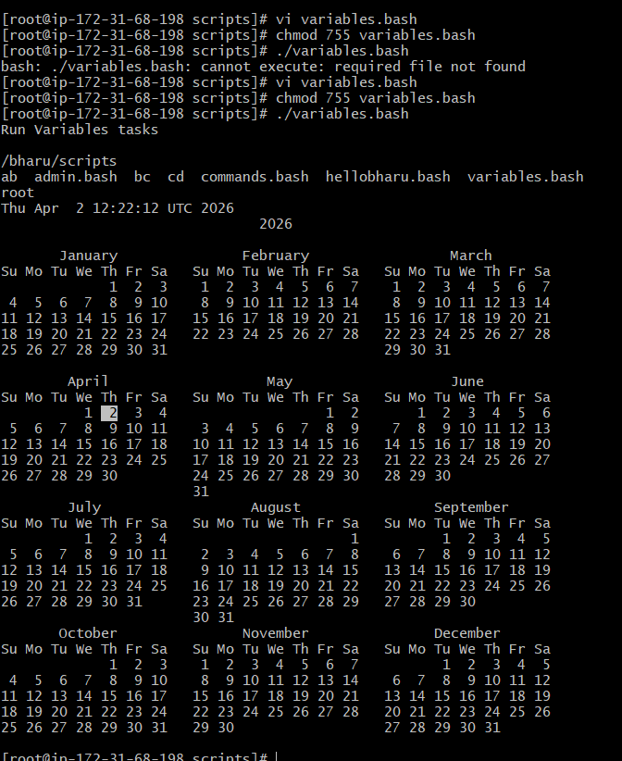
Input and output script:
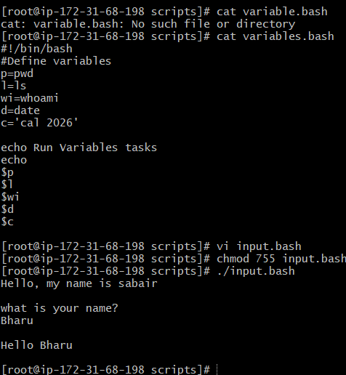
Output variables:
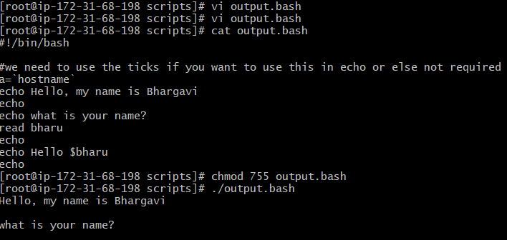

Read input and perform a task: Task 3
Output to screen:
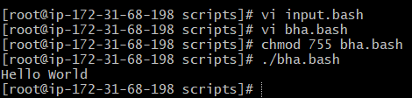
Define a Tasks:
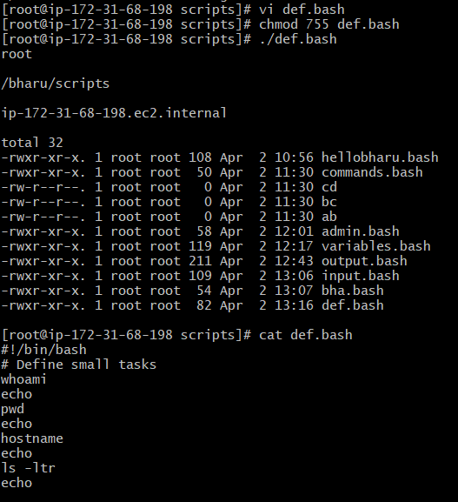
Defining variables:
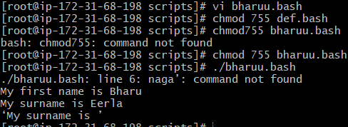
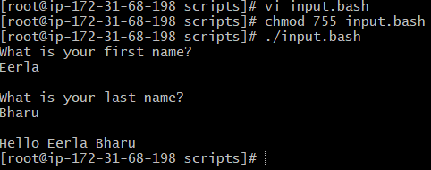
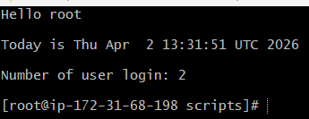
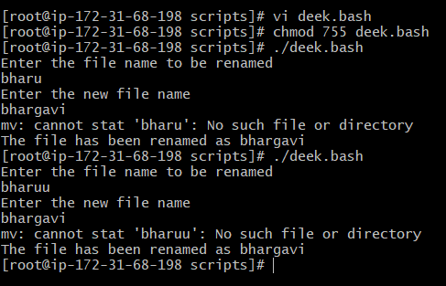
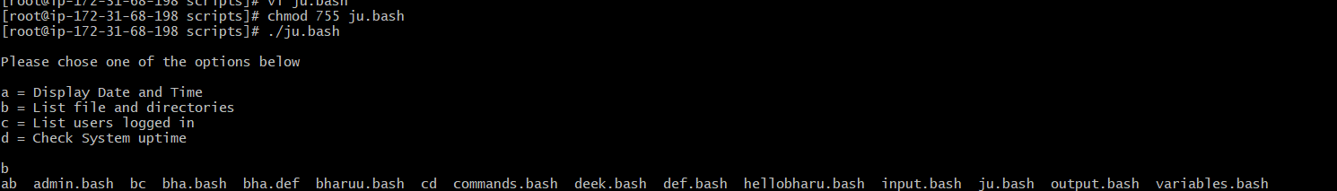
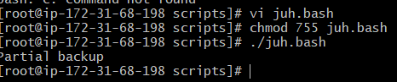
do-while Script
Script to run for a number of times
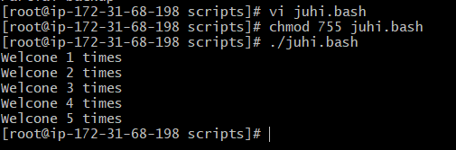
Script to run for a number of seconds
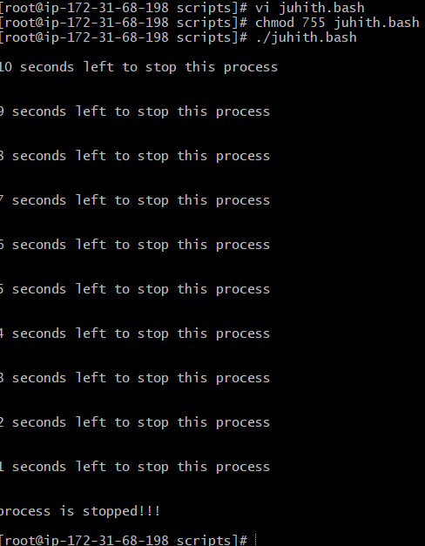
for loop Scripts:
Simple for loop output
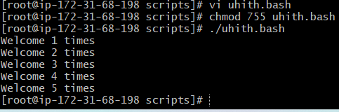

Simple for loop output
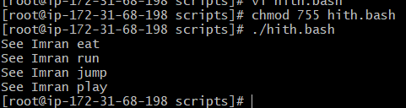
for loop to delete 5 files named 1-5
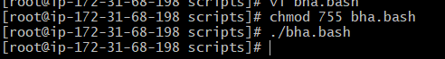
List all users one by one from /etc/passwd file
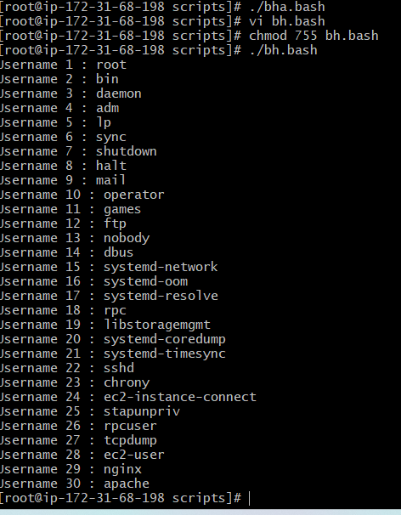
If-then Scripts:
Check the variable
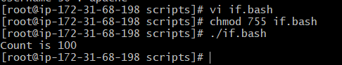
Check the response and then output
